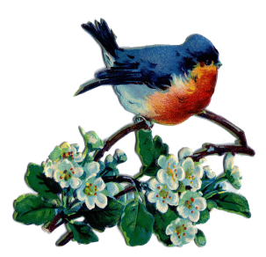***July/August Good News 2022***



**Our ministry vision for the Virginia Annual Conference is *“to be disciples of Jesus Christ who are lifelong learners, who influence others to serve.”***

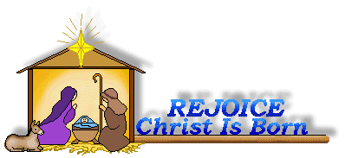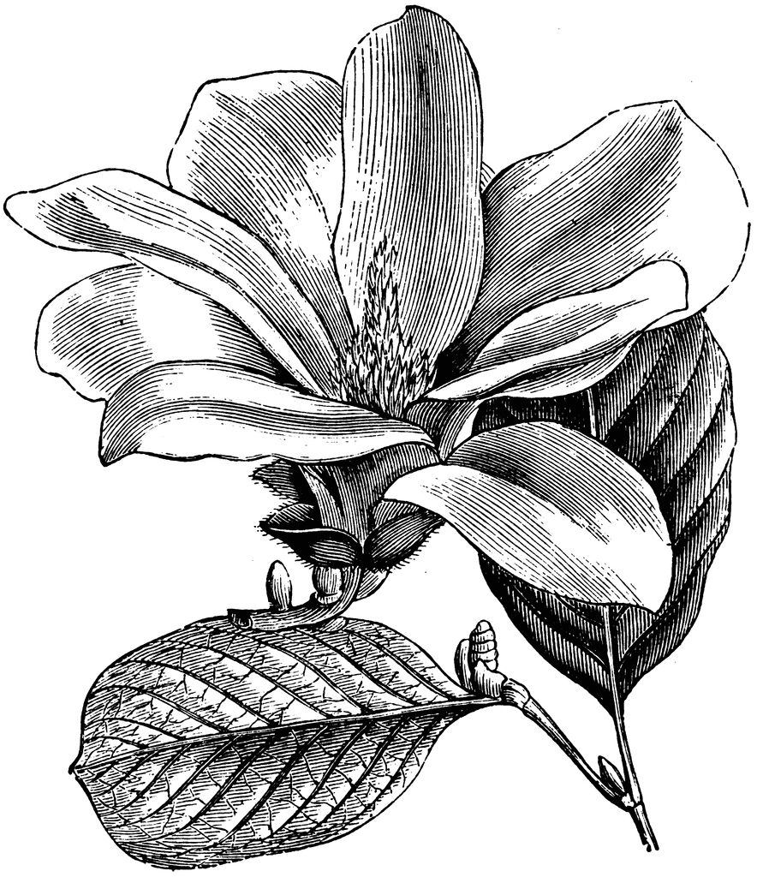

**From Pastor Adam**

***“Security in Changing Seasons”***

*For everything there is a season, and a time for every matter under heaven...*(Ecclesiastes 3:1)

*God is our refuge and strength, a very present help in trouble. Therefore we will not fear, though the earth should change, though the mountains shake in the heart of the sea; though its waters roar and foam, though the mountains tremble with its tumult.*  (Psalm 46:1-3)

*O God, our help in ages past, our hope for years to come, our shelter from the stormy blast, and our eternal home!*  (Isaac Watts, 1719)

Change is never easy. Even when the result of the changes in our lives bring positive result, still change is not easy – especially at the beginning of the change or at the end of a beloved and celebrated season. One might think that simply admitting that “change is not easy” and always inevitable would make change more manageable, but that is not always the case. Given the basic human difficulty with change, it seems rather bold that the writer of Ecclesiastes can say *“for everything there is a season, and a time for every matter under heaven.”* The words may strike us as all too optimistic or dismissive of the real discomfort that comes with change. But what undergirds those words is the affirmation found throughout scripture and held deeply in the consciousness of believing people – and that is: amidst the changing times and seasons, God’s presence with us, love toward us, God’s commitment to God’s people, and the ultimate triumph of the church means that peace, well-being, and goodness can be found in every season of our lives and in the life of our various congregations.

It is true that we are adjusting to a change that has come as our Associate Pastor, Steve Stadtherr follows the call of the church to serve Providence and White’s United Methodist Churches. We have witnessed Steve’s growth in his gifts for ministry, his strength as a preacher, and his love for all of us. As Steve begins a new adventure, we can see the fruit of the good things we have poured into his life over the past year. In other words, as he goes forth, he carries a bit of us with him. As he goes forth, we do not fear because God is with us and for us (just as God is with and for the people of Providence and White’s UMC) as Psalm 46 remind us so well. But more than mere fearlessness – because God is with us and for us – we are able to feel some of the joy of the larger, broader church as Steve gifts and contribution expand beyond the four walls of Chestnut Hill.

Meanwhile, we look forward to the arrival of *Erin Long* who will serve as our “new” Associate Pastor beginning the first of July. Because God is our refuge and strength, we know that God is already preparing her, strengthening her, and sharpening her skills for the work that awaits. In our style of doing church, we are often in the place of saying “goodbye” and “hello” at the same time, as pastors enter and depart our lives. Knowing the deep warmth and goodwill of the people of Chestnut Hill, I have full trust that we will engage in this transition well, both for our sake and the sake of Gospel.

Godspeed, Steve! We love you, and you have served us well! Thanks be to God. Peace, ~Adam

Blest Be the Tie That Binds

This past year serving and

fellowshipping with you at Chestnut Hill United Methodist Church has been pure

joy for me! You welcomed me, supported me, nurtured me, mentored me, and loved me. I have grown so much in my ministry because of you. When I joined you in July 2021, I did not realize that our time

together would be so short and come to such an unexpected and abrupt end. I had hoped I would continue growing in my

ministry with Chestnut Hill for years to come. I had a choice in the decision that was made and I am not sure if I made the correct one, only time will tell. What I do know is that my heart remains with the

people of Chestnut Hill and although I am not looking to go into the ministry

full-time, and if I am to continue this journey, I need to give this new opportunity a try and let God direct my paths and see where he leads me. I will either continue

on to certification or decide that my calling was to be a teacher of the Gospel, not a preacher. We will just have to see. Since God is my rock and my fortress, for the

sake of His name, I am allowing him to

lead and guide me. *(Psalm 31:3)*.

Saying good-bye to you all certainly does give me inward pain. You are my first and like all firsts – first car, first love, first born – you will forever hold a special place in my heart. I will never forget the love, laughs, songs, prayers, and tears we have shared. Each of you is special in your own way to me. Thank you for the many memories. And, although I will not be present with you any longer on Sunday mornings for worship, I hope that you will feel my presence in spirit and Christian love and know that we shall be joined in heart and hope to meet again.

With gratitude and blessings,

~*Pastor Steve*



Welcome to our new

Associate Pastor

***Erin Long*** was raised in Warrensburg, Missouri and has been in Lynchburg for over a decade. Erin grew up in the Presbyterian church. Erin has been attending Peakland United Methodist Church and participating in their missions team, as a liturgist and helped co-lead a small group. Erin attended seminary at Fuller Theological Seminary Southwest and main campus in Pasadena, CA and earned a Master of Arts in Theology. Erin is also a licensed marriage and family therapist and attended Louisville Seminary in Kentucky.

Erin currently works full time as a Mental health consultant at Lynchburg General Hospital. Erin is looking forward to meeting and working with everyone at Chestnut Hill United Methodist.

**Graduate**

**Congratulations to…**

**Hope A. LeFew** graduatedin the Centra Nursing program as a RN. She is working in Womens Baby Care at Virginia Baptist.

**Choir News**

We will break for summer! We will resume on Thursdays at 6:30 p.m (subject to change) in August. Come and lend your voice. All are invited!!

~**Heather Wilson, Director of Music**

**Circle News**

 The **Merry Marthas Circle** will meet on Wednesday, July 13, for ice cream at "Outside The Cone" in Wyndhurst on Enterprise Dr. It is on the left coming from Forest Rd. The sign over the door says "Handcrafted Ice Cream". We will meet there at 2:00. There is parking in back of the building, as well as on the street. If you are not comfortable driving there, let me know. I can pick up 4.

We will not meet in August, but will resume regular 2nd Wednesday meetings on Sept. 14 at church. ~*Judy Robertson*

* * * * * * * * * * * * * * * * * * *

The **Wesleyan Group** is not meeting in July. We will meet on Tuesday, August 8th, at the Legacy Oaks Clubhouse (100 Legacy Oaks Place. In Mary Walker’s neighborhood).

*Mission Memo*

In June we collected 47lbs. of cereal and miscellaneous food items for Park View Mission. Park View was grateful for these donations and for our church’s faithful support for this mission.

Looking ahead to the public schools early start, for July and August we will collect canned meats and fruit. They have requested we purchase easy-open cans that can be opened by hand. I think the snack size fruit cups will be fine. Thank you to all who support this outreach mission.

~*Thank you the Mission Committee*

Thank you Chestnut Hill UMC for your generosity and continued support. It means so much to us that you collect specific items that our neighbors need. Our neighbors were so excited to receive cereal. Thank you!

Bri Barnwell, Manager, Food for Families

Park View Community Missions

~*Thank you the Mission Committee*

**Food Cart...**

 Items needed for the Food Cart for ***Park View Community Mission.***

For the Months of  **JULY/AUGUST**

**Canned Meat** and **Canned Fruit.**

*Place donations in the grocery cart, located in the Commons*. **No “*baked goods*” of any kind.**

*Place donations in the grocery cart, located in the Commons*

*Gifts & Memorials*

**In Memory:**

*Thelma Hamilton*

Given by: Vernelle Roupe

*Carolyn Stewart*

Given by: Frances Unruh, David & Eleanor Maxham, Dan & Judy Robertson, Cheryl & Danny Williams, Cindy Carter, Libby & Gary Carter, Barbara LeFew & Family, Bob & Eleanor Elium, Herman & Rebecca Steward, Jimmy & Barbara Blunt, Bob & Elaine Clarke, Beryl Martin, Rennie White, Chet & Mary Walker,J. Owen Stinnette, Robbie Perrow, Steve & Annette Stadtherr, Bill & Margaret Turley, Ken & Susan Sommerkamp, George & Susan Beasley, Wilton & Kitty Burgess, Fred & Sue Norvelle, Economic Development Authority of Botetourt Co. (Daleville),County Administrator of Botetourt County (Fincastle), Wes & Ann Robbins, Jay & Kathryn Sommerkamp



In Memoriam

*Carolyn Joyce Winslow Stewart*

November 30, 1950 – May 27, 2022

*Chestnut Hill United Methodist Church extends Christian love and sympathy* to the family of *Carolyn Joyce Winslow Stewart* and especially to her husband, Frank, and daughters, Magdalena Heather Price and Kim Stewart.

*Trust in the Lord with all thine heart”* Proverbs 3

I am grateful to have such a loving church family and your expressions of sympathy during mom’s passing, on April 23rd, have been of great support and comfort.

God bless! *Carolyn Sue Almond*

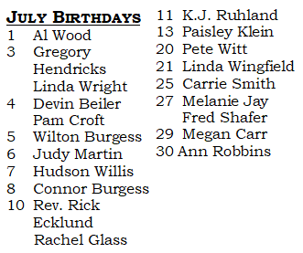

**2022**



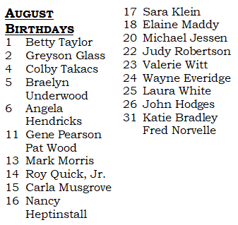

|  |  |
| --- | --- |
| **Those Who Serve~JULY**  **GREETERS:**  **July 3** ~Ann Robbins  **July 10 ~**Judy Robertson  **July 17** ~Tucker Cole  **July 24** ~Jane White  **July 31** ~Mary Walker  **MONEY COUNTERS:**  Maggie Musgrove  Brenda Torian  **Those Who Serve~AUGUST**  **GREETERS:**  **August 7** ~Dan Robertson  **August 14** ~Betty Taylor  **August 21** ~Ann Robbins  **August 28** ~Judy Robertson  **MONEY COUNTERS:**  Ann Robbins  Linda Wright  **GOOD NEWS** is published monthly for members and friends of Chestnut Hill United Methodist Church. Send articles to the church office by the 15th of the month. **(Subject to change.)**  + + + + + + + + + + + + + + + + + + + + + + + | **Our Church Financial Picture**  Through the end of May 2022  General Operating Funds:  Needed to meet our 2022 Budget $ 194,759.00  Needed to meet our budget to date $ 81,150.00  Actual receipts to date $ 78,502.00  Shortage to meet budget to date $ 2,648.00  Actual expenditures to date $ 65,595.00  Overage to meet expenses to date $ - 12,907.00  Joy In Missions Funds:  Our Giving Goal for 2022 $ 11,600.00  Needed to meet our goal to date $ 4,833.00  Actual receipts to date $ 4,420.00  Special Offerings* (not budgeted):  Received to date $ 12,525.00  Dispersed to date $ 12,430.00  *Christmas, Easter, Annual Conference,  World Communion, etc.  **2022 Joy In Mission Donations**  To date, the following amounts have  been paid to the missions indicated.  Budget Spent  1. Missionary Covenant Relationship $1,000 $250  2. Interfaith Outreach $1,000 $250  3. Park View Mission, Food for  Families $3,000 $955  4. Society of St. Andrew $1,000 $250  1. Adult Care Center $ 500 $125  2. Blue Ridge Area Food Bank $ 1,000 $250  3. Camp Timothy $ 500 $500  4. Churches for Urban Ministry $ 500 $0  5. Daily Bread $ 500 $125  6. Free Clinic $ 500 $125  7. Good Neighbor $ 500 $0  8. Habitat for Humanity $ 500 $125  9. UMCOR-Non-Administrative $ 500 $0  10. Undesignated $ 600 $0  Thank You for Your Generosity |

**March 2022**

January 2022



**2022**

|  |  |  |  |  |  |  |
| --- | --- | --- | --- | --- | --- | --- |
| **Sunday** | **Monday** | **Tuesday** | **Wednesday** | **Thursday** | **Friday** | **Saturday** |
|  | | | | | **1 Office Closed** | **2** |
| **3 *4th Sunday after***  ***Pentecost***  9:30am Sunday School  10:30am Worship | **4**          **Office Closed** | **5**  8:30am Camp Meadowlark | **6**  8:30am Camp Meadowlark | **7**  8:30am Camp Meadowlark | **8**  8:30am Camp Meadowlark | **9** |
| **10 *5th Sunday after Pentecost***  9:30am Sunday School  10:30am Worship | **11**  8:30am Camp Meadowlark | **12**  8:30am Camp Meadowlark | **13**  8:30am Camp Meadowlark  1:00pm Merry Marthas @ Outside the Cone (Wyndhurst) | **14**  8:30am Camp Meadowlark | **15**  8:30am Camp Meadowlark | **16** |
| **17 *6th Sunday after Pentecost***  9:30am Sunday School  10:30am Worship | **18**  8:30am Camp Meadowlark | **19**  8:30am Camp Meadowlark | **20**  Camp Meadowlark Meeting  8:30am Camp Meadowlark | **21**  8:30am Camp Meadowlark | **22**  8:30am Camp Meadowlark | **23** |
| **24 *7th Sunday after Pentecost***  9:30am Sunday School  10:30am Worship | **25**  8:30am Camp Meadowlark | **26**  8:30am Camp Meadowlark | **27**  8:30am Camp Meadowlark | **28**  8:30am Camp Meadowlark | **29**  8:30am Camp Meadowlark | **30** |
| **31 *8th Sunday after Pentecost***  9:30am Sunday School  10:30am Worship |  | | | | | |





|  |  |  |  |  |  |  |
| --- | --- | --- | --- | --- | --- | --- |
| ***Sunday*** | **Monday** | **Tuesday** | **Wednesday** | **Thursday** | **Friday** | **Saturday** |
|  | **1** | **2** | **3** | **4**  *Church Office Closed* | **5** | **6**  Homeschool Open House |
| ***7 9th Sunday after Pentecost***  *9:30am Sunday School*  *10:30am Worship* | **8** | **9** | **10** | **11** | **12**  10:00am Homeschool Orientation | **13** |
| ***14 10th Sunday after Pentecost***  *9:30am Sunday School*  *10:30am Worship* | **15** | **16** | **17** | **18** | **19**  10:00am Homeschool | **20** |
| ***21 11th Sunday after Pentecost***  *9:30am Sunday School*  *10:30am Worship* | **22** | **23** | **24** | **25** | **26**  10:00am Homeschool | **27** |
| ***28 12th Sunday after Pentecost***  *9:30am Sunday School*  *10:30am Worship* | **29** | **30** | **31** |  | | |



**April 2022**

**April 2022**

**March 2022**



*Chestnut Hill United*

*Methodist Church*

4660 Fort Avenue, Lynchburg, VA 24502

Phone Number: 434-239-8423: FAX: 434-239-7209

E-mail: [chestnuthillumc@comcast.net](mailto:chestnuthillumc@comcast.net)

On the web: www.chestnuthillumc.net

Church Office Hours

**Monday-Thursday~**9:00 am—3:30 pm

**Friday~**9:00 am-1:00 pm

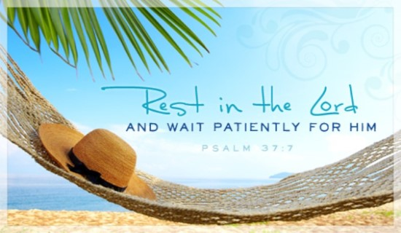

***DIRECTORY OF***

***CHESTNUT HILL UNITED METHODIST CHURCH***

|  |  |  |
| --- | --- | --- |
|  | Sharma Lewis | Richmond Area Resident Bishop |
|  | Denise Bates | Lynchburg District Superintendent |
|  | Adam White | Minister |
|  | Erin Long | Associate Minister |
|  | Monica C. Campbell | Administrative Assistant |
|  | Heather Wilson | Director of Music Ministry |
|  | Judy Martin | Bookkeeper |
|  | Judy Robertson | Lay Leader |